CSC421/CSC2516 Winter 2019 Homework 1

1. Hard-Coding a Network

$W^{(1)}= \left[\begin{matrix}1 & -1 & 0 & 0 \\ 0 & 1 & -1 & 0 \\ 0 & 0 & 1 & -1\end{matrix}\right]$ $b^{(1)}=\left[\begin{matrix}0 \\ 0 \\ 0\end{matrix}\right]$ $W^{(2)}=\left[\begin{matrix}-1 \\ -1 \\ -1\end{matrix}\right]$ $b^{(2)}=0.9$

1. Backprop

2.1

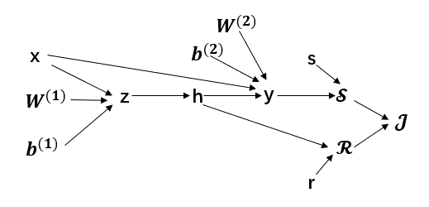

2.2

$\overline{J}$ = 1 =

+ r

$$\overline{z}=\overline{h}* \frac{∂_{h}}{∂_{z}}=\left\{{\left[W^{\left(2\right)}\right]}^{T}\left(y-s\right)+ r\right\} ∘σ^{'}(z)$$

$\overline{x}=\overline{z}* \frac{∂_{z}}{∂_{x}}+\overline{y}* \frac{∂_{y}}{∂_{x}}$ = ${\left[W^{\left(1\right)}\right]}^{T}*\overline{z}+ \overline{y}*1$

= ${\left[W^{\left(1\right)}\right]}^{T}[\left\{{\left[W^{\left(2\right)}\right]}^{T}\left(y-s\right)+ r\right\} ∘σ^{'}\left(z\right)]+ y-s$

1. Sparsifying Activation Function.

We can check the value of derivatives using backprop. Here we use $z_{i}$ to denote the input of Relu activation unit $h_{i}$.

$\frac{∂L}{∂w_{1}}$: Yes. $\frac{∂L}{∂w_{1}}=\overline{y}*\frac{∂y}{∂w_{1}}= \overline{y}*h_{1}=\overline{y}*0=0$

$\frac{∂L}{∂w_{2}}$: Yes. $\frac{∂L}{∂w_{2}}=\overline{y}*\frac{∂y}{∂h_{1}}*\frac{∂h_{1}}{∂z_{1}}*\frac{∂z_{1}}{∂w2}$

Since $z_{1}=-1,$ and $h_{1}=Relu\left(z_{1}\right),$ we have $\frac{∂h_{1}}{∂z_{1}}=0,$ thus $\frac{∂L}{∂w_{2}}=0$.

$\frac{∂L}{∂w_{3}}$: No. Since both $h_{2}$ and $h_{3}$ can be positive, if we change $w_{3}$ a little, the value of $h_{2}$ and $h_{3}$ can be changed, then y will correspondingly change. Therefore, the derivative can be nonzero.